PARC May 5, 2021 4:30 pm BOD Meeting minutes

Summary:
1. Last month’s meeting minutes.
2. Chair report:
April 24, Computer workshop a success
LTTE results so far no response. Still trying.
Policy needed for post card outreach.
Request for 2020 election voting statistics in process
Organizational questions in process

3. BOD members reports
Treasurer Linda M. All ok.
Secretary Marlene R. reported on use of Spectrum Marketing to communicate our events across all of New Hampshire.
Membership. Glen C. No report
IT Media Bob Hatcher. Suggested a post card process where pre messaged Post cards are available to each DWF attendees. Suggestion very well received. Follow up needed for a policy to govern.
Planning / Fundraising: Kendall Hughes has organized a raffle. Tickets to be available soon.
Past Chair, Advisory Board Roy Russel: A few irons in the fire.

4. New Business:
Tentative plans for a Movie night in the works.
Need to review and or augment candidate funds disbursement policy.
Election to be conducted at the June 10 DWF meeting.
Need a list of full members for ballot distribution at the door.
Secretary to tally & announce results at the meeting.

A. Attendance:
In attendance were Dave R., Marlene R., Linda M., Bob H., Roy R., Haley V-L., Kendall H.,

B. Last Month’s meeting minutes:
April 2021 (March 31, 2021) meeting minutes: reviewed & approved

C. Dave R., Chair report:
1. The April 24 Computer Workshop was a success.
Lesson learned: if we repeat, it may be best to limit to five or six people and try & schedule time slots.
2. I am assisting County’s development of new county bylaws. First draft complete, seeking feedback.
3. LTTE Submitted guidelines and topics for potential letter writers starting with a report ”How your Reps voted”. We may need to revisit strategy to get members to communicate to newspapers & our elected officials. Response has been disappointing.
4. Board did not disagree to the notion that we need a policy governing using our mailing list as a call to action: Suggested: “All requests to use our mailing list must be approved by the Chair. The Chair must exercise restraint so that we do not over use and abuse contacting our members & friends.”
Need more discussion.
5. I will be following up with State GOP Offices to request voting statistics for all 2020 Grafton County State Rep candidates. The intent is to find strengths, weaknesses, opportunities & threats to 2022 campaigns.
6. The State GOP is still suggesting we formally organize as a PAC. I have asked the State GOP and the 603 Alliance for some assistance in understanding this. I will not agree to anything unless backed up by the Board.

D. Treasurer report: Linda M. Assets / Liabilities.
Except for the pending purchase of raffle prize we have no outstanding liabilities. Assets far outweigh liabilities.
Exact numbers are available to any board member by simply asking Linda. We decided to not publish this data.

E. Secretary Marlene R. report.
Marlene reported that she is sending our meeting information to Spectrum Marketing a conservative friendly organization who publish a weekly newsletter listing all current Republican events. Marlene has sent a copy of Spectrum’s newsletter e mail to all BOD members. One may subscribe to this news letter from a link in the newsletter itself or send them an e mail using their e mail address: theweekly@spectrumarketing.com.

Marlene also communicates with the State GOP to obtain liability coverage for each of our events.

She is also reliable supplier of delicious homemade cookies & cakes for our DWF’s as are many of our BOD members and members spouses, as well as some regular members all of which we really appreciate!

F. Membership: Glen C. report.
Absent, No report.
Further discussions with Glen have resulted in his working on a New Member Welcome process.

G. IT/ Communications: Bob H. report.
Bob reported that during his activist training that he found an idea for us to consider: Unstamped post cards with a preprinted message and a preprinted address that we would hand out at DWF meetings. Two to an attendee asking them to sign and stamp and send AND to give the second one to a friend for them to do the same thing.
Very positive feedback.
This should be supported with the to be developed policies mentioned in sections C 3 and C4 above.
Issues to be discussed: Who best to send these to:
Washington DC Democrats
Washington DC Republicans
State and local Democrats
State And local Republicans

Web site is looking very good.

H. Past Chair Advisory committee: Roy R. report.
A few irons in the fire. Grafton County is also working on a big event and are close to lining up a big name speaker. We have volunteered to participate in their organizing committee to learn the process and to also share in the outcomes.

I. County Liaison subcommittee: Holly W. report
Holly has met with Convention of States Action District Captain Eric Strapp who has agreed to give a 10 minute overview of his organization and its goals at our June 10 DWF meeting.

J Student Outreach: Hayley Van Loon report
Haley reported that she has reached out to Christine Brennan at the NH State Education Commissioner’s office for assistance.

K. Planning / Fund Raising: Kendall Hughes
Kendall has been involved with a number of raffles in the past and is in fact running one right now for the Ashland Fire Department. He has assisted in locating Littlefield’s a firearms dealer in Plymouth who we will purchase our raffle prizes from and who will work with the winner to manage all permits.

Raffle breakdown:
500 tickets $10 each, 5 for $40.
Award a 9mm Luger pistol. -Drawing to be held at a special PARC event:

Raffle Est. revenue:
Pistol and box of ammo approximately $525.
Ticket printing: Approximately $200
Cost Total EST $725:
Gross income total EST: 100 each of $40 sets of five tickets: $4000
Total est. net from raffle: $3275.

Note: Breakeven:
78 tickets at $10 = $780
20 books of 4 @ $40 ea.= $800

This was put to a vote: Kendall H. motioned, Linda M. Seconded. All voted in favor.

L. County Liaison Sub Committee report:
Holly Willoughby: See section I above. Convention of states contact.

M. Student outreach Sub Committee report:
Hayley Van Loon: See section J above: NH Education Commission contact.

New Business...
A. Letter writing:
I sent an email to each of the 21 people who volunteered to participate in our letter writing group providing ideas and a process for them to become involved.
Note that the NGCRC has a form on their web site for people to use to send letter drafts in to the GCRC for processing. Something we may look at doing in PARC.

B. Fund raising / (Special Event(s)
Movie night at the American Legion. Dessert & Popcorn.
We have producer’s permission to run and charge admission for the movie: Climate Hustle2…Climate Hustle 2 dives headlong into the overhyped scientific claims and motivations of those clamoring for immediate action to address global warming. Hosted by actor Kevin Sorbo and featuring leading scientists, politicians, celebrities, and policy experts, the film showcases blatant Hollywood hypocrisy, financial corruption, media bias ...
Other movies…note; we need distributor’s permission to show.

C . Email addresses for DWF walk-ins
We should continue our e mail fishbowl collections. It costs zero and we will get new email addresses.
Award should be equal to the admission fee ($10).

D. DWF Event dates
Consensus was that we should continue with the 2nd Thursday of every month for our DWF events.

E. Need to review our bylaws and/or develop a process for PARC to follow concerning candidate disbursement of funds.
From the bylaws:
Candidate Support:
The PARC will favor candidates for office who when elected will serve in towns within our catchment area. Support will be in the form of direct or indirect (mailings for example) financial contributions, sign placement/removal, door knocking, phone banking, poll standing and the like.
We will ask in return that the candidates who we financially support to be members of the PARC and ideally to contribute to our discussion forums periodically. Financial support requires an acknowledgement from the candidate that they are in need of funds and a majority approval of the PARC BOD.
F. Schedules

* BOD Meeting schedule
- June 2, Wednesday BOD Meeting: Prepare for BOD election
- July, no meetings unless emergency.
- August, no meetings unless emergency
- September 1, Wednesday BOD meeting.
- October 6, Wednesday: BOD Meeting.
- November 3, Wednesday BOD Meeting.
- December 1, Wednesday BOD Meeting

* DWF Meeting schedule
- March 18 Thursday DWF
- . From now on: DWF MEETINGS EVERY SECOND THURSDAY.
- June 10 DWF: BOD election, Eric Strapp Convention of States 10 min, & General Donald Bolduc.
- July / August: No DWF meetings.
- September 9 DWF: Mark Alliegro
- October 14 Daniel Richards (need confirmation…)
- November 11 DWF ((This is Veteran’s day…ok?)
- December 9 DWF meeting or holiday potluck gala?

G. BOD first annual BBQ / Celebration July 24, 4:30 ---
Home of Dave & Marlene Rivers. No PARC $.
Including Past BOD member invitations for John R., Mike M., and special guest Mark A.

H. BOD election: June DWF 2021.
Will require a list of Paid members for at the door ballot handouts
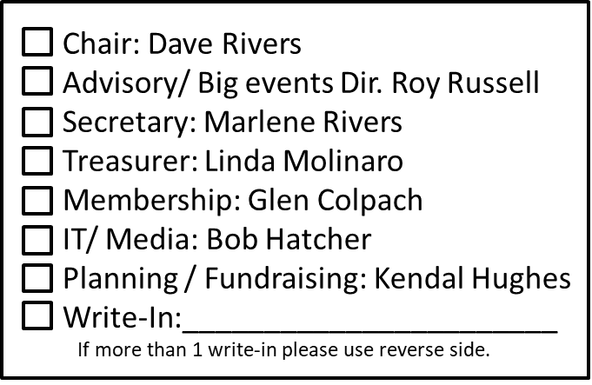
Current
Member
List.
Member?
Complete
Ballots
Secretary &
Volunteer
Collect &
Count Ballots.
No Ballot
Secretary
Announce
Results.

end.

